Christmas Day, but updated
on January 3, 2005
168 Dos Brazos
Los Alamos, NM 87544

Feliz Navidad y Prospero Año Nuevo,

It was a white Christmas here. We may have emerged from our five years of drought. Pajarito Mountain opened December 3, one of the earliest times we can remember. (Often we don’t start skiing here until January, sometimes in recent years even February.)
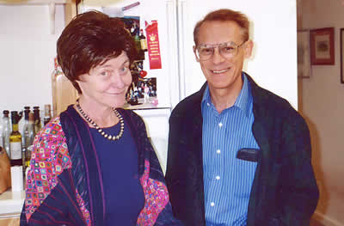

We missed the opening, being involved with the annual Kiva Classic squash tournament in Santa Fe. Two days later, we headed up to Colorado to try out our new ski passes for Summit County. The eight days there have “already paid for it”, provided you don’t count what we had to spend in lodging and vittles. Back again, we got in another 6 days skiing. Christmas being a day of closure, I got to make the pancakes and start writing this annual update-letter. Following that we have gotten in another 8 days at Pj Mtn. Good snow, more to come this week!

In the spring of the year, we turned to household chores long neglected. I repainted walls and patched the roof where the crows had been chewing on it. With interludes of squash tournaments in Colorado Springs and Denver. And a longer one, April, visiting friends and hiking in der Ostschweiz and Ticino. June was spent rejuvenating our burned-out lawn and clearing out our overstuffed garage. Isn’t retirement wonderful?

Summer was spent locally, since that’s when most of the visitors to the Laboratory come. And then, of course, the Laboratory went into a severe “stand-down”, which wasn’t pleasant to watch, even though from a distance. It seems to be in a recovering state now, but there still is much uncertainty about whether it will continue to be administered by the University of California.

In September we went back on the road for another month-long driving trip to Northern California. We hiked and camped, including one night at 16 degrees below freezing and in snow in Tuolumne Meadows. There was yet another doubles squash tournament (with my tall, left-handed partner from Fresno), in which we defeated a 35-year-old ex-president of the US Squash Racquets Association in the first round. (In honesty I have to add that we started out with the advantage of an 18 point handicap.) We lost in the finals.

That’s been our year, if you don’t count our national election. We wish you all a happy holiday season and a prosperous new year.

Dick and Maggie Silbar

